12/10/2026
Resego Monnapula 202418288 Zandilsile Maxwell Mtlathi 202217157 Tlotlo Valentine Mochwiri 202426962

Group 4
Vantage: Micro-Business (Inventory) Management System
PROJECT PHASE 4: IMPLEMANTATION & PRESENTATION PROJECT (20262FNPRT630)

1. Introduction
This final report consolidates the work completed across all four project phases of the Vantage Micro-Business Inventory Management System. Phase 1 established the problem of manual record-keeping among South African micro-businesses (spaza shops, clothing stores and repair services) and quantified the inefficiencies (60–90 minutes daily spent on stock counting, 10–15 % potential sales loss from stock-outs, and 1–3 % error rates in profit reporting). Phase 2 produced the functional and non-functional requirements together with the UML artefacts and project-management plans. Phase 3 translated those requirements into detailed user-interface designs, an entity-relationship model and a technology selection. Phase 4 delivered a working Java desktop application that implements the core inventory, sales and role-based features designed in the earlier phases.
The system was realized as a Java Swing desktop application with MySQL persistence, aligning with the module’s prescribed technology requirements (Java programming and SQL database connectivity). The remainder of this report documents the implemented functionality, demonstrates requirements coverage, records the testing performed, explains deviations from the original web-based design, and reflects on the team’s learning.

2. Technology Stack and Architecture
Layer | Technology | Role
Presentation | Java Swing | Login, Register, Dashboard, Product, Stock, Sales, Reports, Manage Users windows
Application Logic | Java | Authentication, role checks, stock updates, sales calculations, user approval workflow
Data | MySQL via JDBC | Persistent storage of users, products, categories and sales
Development | VS Code / NetBeans IDE | Development, debugging and packaging

The application follows a simple three-layer separation: Swing windows handle user interaction, Java classes encapsulate business rules (stock deduction, total calculation, access control, user approval), and a JDBC data-access layer communicates with MySQL.

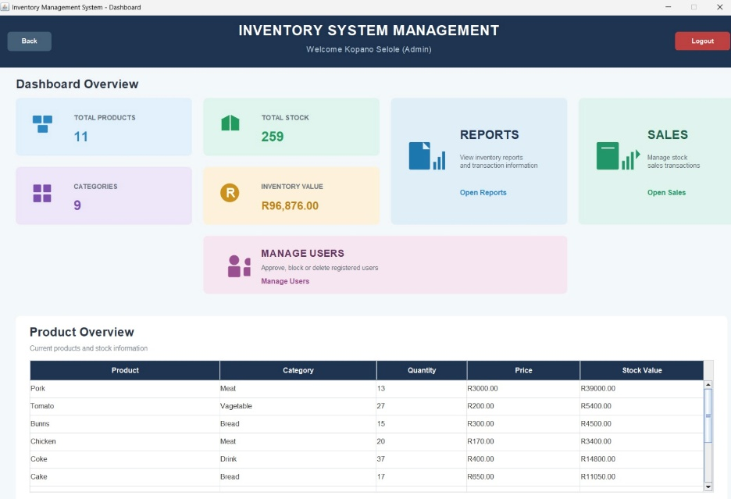
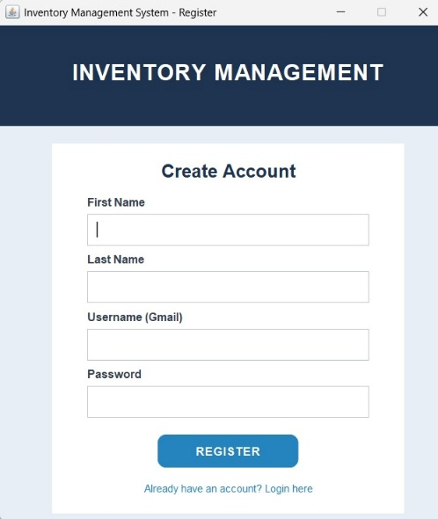
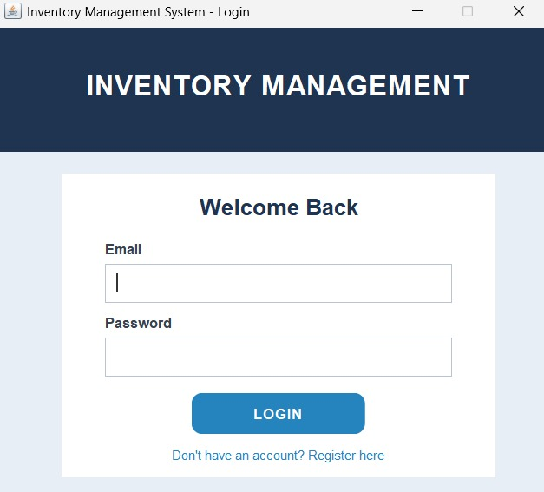
3. Implemented Modules and System Walkthrough
Figure 1 – Login and Register Users authenticate with email and password. Successful login routes the user to the role-specific dashboard (Admin or Staff). Accounts that are not yet approved by an Admin receive a “pending approval” message; blocked accounts are denied access.

Figure 2 – Admin Dashboard
Displays key performance indicators (total products, units in stock, number of categories, inventory value) together with a product-overview table and navigation buttons to Reports, Sales and Manage Users.

Figure 3 – Stock Management
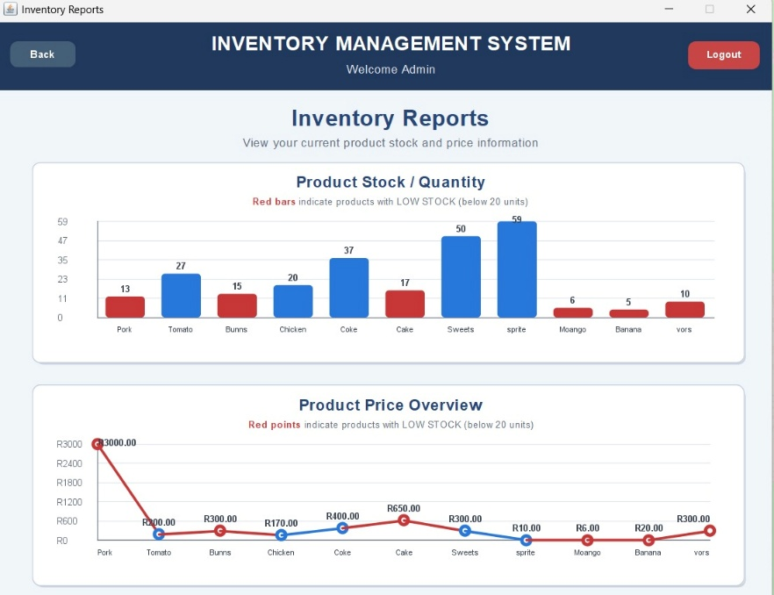
Allows an Administrator to select a product and perform Add Stock, Remove Stock or Update Price operations.

Figure 4 – Sales
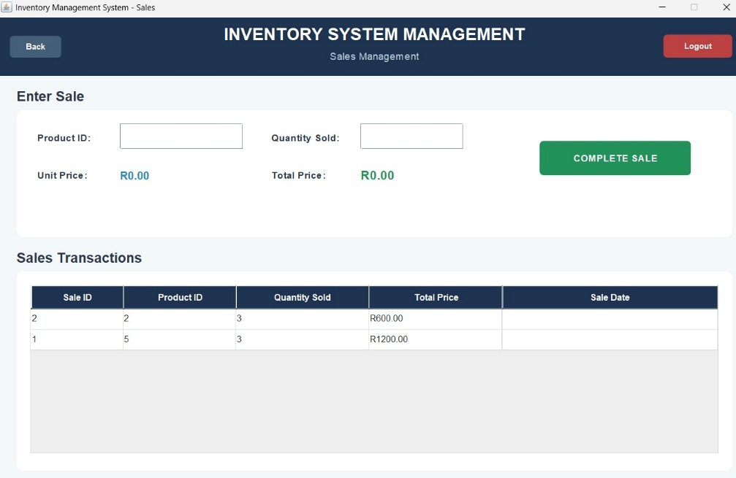
Records a sale by product ID and quantity. Unit price and total are calculated automatically. Completed transactions appear in a list.

Figure 5 – Role-Based Access Control
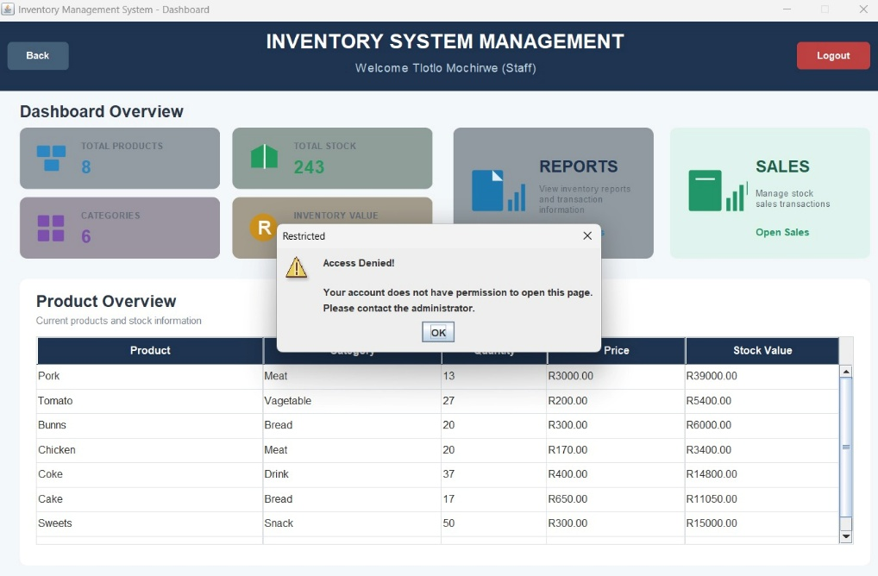
A Staff user attempting to open a restricted function receives an “Access Denied” message and remains on the dashboard.

Figure 6 – Manage Users
The Admin can view all registered users, see their status (Pending / Approved / Blocked / Rejected), and perform the following actions: Approve (grants system access to a pending staff account), Reject (permanently denies a pending account), Block (revokes access from an approved staff account), and Delete (permanently removes the user from the database).
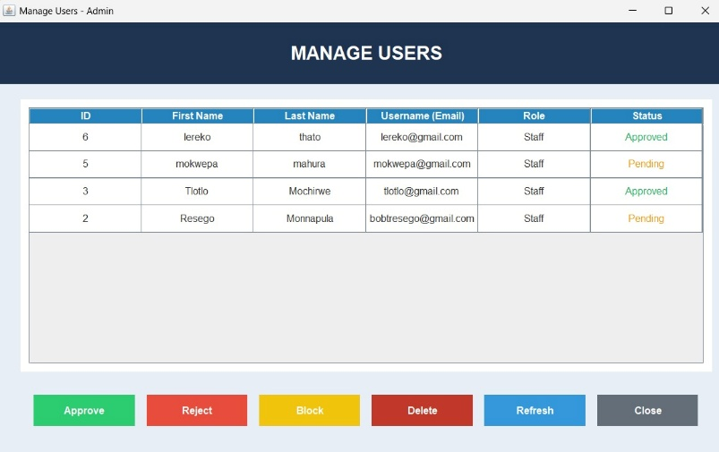

Figure 7 – Registration with Approval Workflow
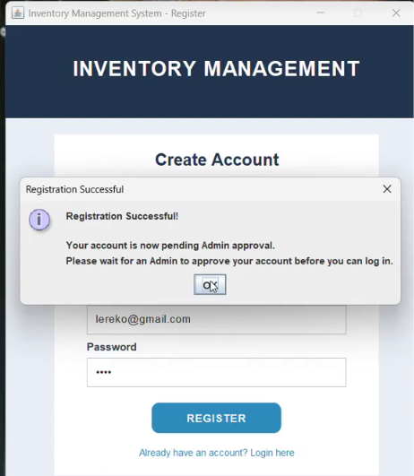
New users self-register via the Register window. On submission, the account is stored with role Staff and status Pending. The user is informed that an Admin must approve the account before login is permitted.

4. Requirements Traceability
ID | Requirement (Phase 2) | Status | Evidence / Notes
FR1 | Register with unique email and password | Implemented | RegisterForm.java; email uniqueness enforced by UNIQUE constraint on the UserName column. New accounts default to role Staff, status Pending.
FR2 | Verify credentials at login | Implemented | Figure 1; Admin & Staff accounts demonstrated. Login_Controller returns distinct codes for success, pending, blocked and invalid credentials.
FR3 | Create, view, update and delete products | Implemented | ProductForm.java provides add/delete; StockForm.java provides quantity add/remove and price update; Dashboard shows live product table.
FR4 | Categorise products | Implemented | Category column on Products table and displayed on the Dashboard and ReportForm; 6+ categories visible.
FR5 | Scan barcodes with mobile camera | Not implemented | Recorded as deviation (see Section 6).
FR6 | Record each sale with timestamp and total | Implemented | SalesForm.java records each sale with SaleID, ProductID, QuantitySold, TotalPrice and MySQL auto-generated SaleDate.
FR7 | Reduce stock in real time on finalised sale | Implemented | SalesForm uses a JDBC transaction: INSERT INTO Sales and UPDATE Products SET Quantity = Quantity - ? are committed atomically.
FR8 | Admin approval of new staff accounts | Implemented | ManageUsersForm.java + ManageUsersController.java; accounts default to Pending and cannot log in until an Admin approves them.

5. Code Quality, Testing, Error Handling and Security

5.1 Code organisation
The codebase is organised into four packages that separate concerns:
- view – All Swing windows (LoginForm, RegisterForm, Dashboard, ProductForm, StockForm, SalesForm, ReportForm, ManageUsersForm). Handles all user interaction and UI rendering.
- controller – Business logic (LoginController, RegisterController, ProductController, SalesController, ManageUsersController). Handles authentication, registration, sales transactions, stock updates and user administration.
- model – Domain classes (User, Product). Encapsulates the data structures passed between view and controller.
- database – DBConnection (JDBC connection helper) and Session (in-memory store of the currently logged-in user’s identity and role).
This modular layout supports the maintainability requirement stated in Phase 2.

5.2 Testing performed
Test Type | Planned (Phase 2) | Actual Result
Unit testing | Tested functions | Individual methods (login, register, addProduct, makeSale, updateUserStatus) tested in isolation.
Integration testing | Working combined system | Full workflow tested: register → admin approves → staff logs in → sales recorded → stock reduced → dashboard reflects changes.
User acceptance testing | User feedback | Not formally conducted with external users; internal peer review by the three team members.
Security testing | Secure login | RBAC verified (Figure 5); SQL-injection prevented via PreparedStatement throughout; password storage is plain text (identified as a limitation – see Section 8).
Performance testing | Fast queries | All queries returned within milliseconds on the local MySQL instance. Dashboard auto-refresh every 3 seconds is smooth.

5.3 Sample test cases
# | Test | Input | Expected | Actual
T1 | Login with correct credentials | Valid Admin email/password | Dashboard displayed | Pass (Fig 1→2)
T2 | Login with wrong password | Incorrect password | Clear error, no access | Pass
T3 | Complete a sale | Product ID + quantity | Sale recorded, stock reduced | Pass
T4 | Staff attempts restricted action | Staff clicks Open Reports | Access Denied message | Pass (Fig 5)
T5 | Sell below low-stock threshold | Quantity that crosses threshold | Red bar appears on ReportForm | Pass
T6 | Register new user | Valid first/last name, email, password | Account saved as Staff/Pending; login blocked until approval | Pass
T7 | Admin approves pending user | Admin clicks Approve in ManageUsersForm | Status changes to Approved; user can now log in | Pass
T8 | Admin blocks approved user | Admin clicks Block | Status changes to Blocked; user immediately denied login | Pass
T9 | Admin deletes a user | Admin clicks Delete | User removed from users table | Pass

5.4 Error handling
- Empty fields – All forms validate required input and show a warning dialog (e.g. “Please fill in all fields”).
- Non-numeric input – NumberFormatException is caught when parsing quantity/price and a friendly error dialog is shown.
- Overselling – SalesForm checks the current stock (SELECT Quantity ... FOR UPDATE) inside a transaction and refuses the sale if quantity > currentStock.
- Duplicate email – The UserName column has a UNIQUE constraint; RegisterController catches the resulting SQLException and returns false, which the RegisterForm surfaces as “Email/Username already exists”.
- Lost database connection – DBConnection.getConnection() returns null on failure; every caller checks for null and displays a “Database Error” dialog.
- Transaction rollback – If either the INSERT INTO Sales or the UPDATE Products fails, the transaction is rolled back so the database stays consistent.

5.5 Security
- Role-based access control – is enforced at the UI level: Staff cards are dimmed on the Dashboard and clicking them shows an “Access Denied” message.
- Approval workflow – new accounts cannot log in until an Admin changes their status to Approved.
- Password storage – currently plain text (identified as a limitation; future work would use BCrypt hashing).
- SQL injection mitigation – every database call uses PreparedStatement with parameter binding; no string concatenation of user input into SQL.

6. Challenges, Deviations and Lessons Learned
Area | Planned (Phase 2/3) | Delivered | Reason / Justification
Platform | Web (Node.js + HTML/CSS/JS) | Java Swing desktop | Module requires Java programming and SQL connectivity; desktop solution satisfies the prescribed technology stack.
User roles | Admin / Employee | Admin / Staff | Naming change only; functionality identical.
Sales structure | Sales + Sale_Items (multi-product) | One product per sale entry | Simplified for time; core stock-update logic still present.
Sale timestamp | Required (FR6) | Column present and populated | SaleDate is a MySQL TIMESTAMP column with DEFAULT CURRENT_TIMESTAMP; visible in SalesForm and ReportForm.
Barcode scanning | Mobile camera integration | Not implemented | Scope reduction; not essential for core inventory workflow.
Offline buffer | Required (NFR2) | Not applicable to desktop | Desktop application does not rely on continuous internet.
Cross-browser / mobile | Required (NFR5) | Not applicable | Desktop delivery.
Low-stock threshold | 5 (SRS) / 10 (mock-up) | 20 units | Confirmed value used in ReportForm: products with fewer than 20 units are highlighted in red on both the bar chart and the line chart.
User approval | Not in original plan | Admin approval workflow added | Essential to prevent unvetted staff from accessing the system.

6.1 Technical challenges encountered
- Transactional consistency during a sale – We initially wrote the sale insert and stock update as two separate statements, which risked the stock being reduced without a sale being recorded (or vice versa). This was fixed by wrapping both operations in a single JDBC transaction with setAutoCommit(false), commit() on success and rollback() on failure.
- Wiring Swing event handlers to JDBC updates – Several forms needed to react to user input in real time (e.g. SalesForm recalculating the total as the user types). We used DocumentListener to attach recalculation logic to the text fields, and ItemListener on the product combo box in StockForm to reload the price.
- Enforcing role checks without cluttering every window – Instead of adding if (isAdmin) checks inside every action handler, we centralised the role logic in Session.isAdmin() and applied it at card-creation time in the Dashboard. This kept the individual form classes clean.

6.2 Lessons learned
Earlier integration of the database layer would have reduced late surprises – we only connected to MySQL after the Swing layouts were essentially finished, which meant refactoring the forms to pull data at the correct moments. Clearer ownership of the reporting module would have ensured the charts were completed on schedule. The shift from a web to a desktop architecture, while necessary to meet the module’s technology prescription, highlighted the importance of validating technology choices against institutional requirements at the proposal stage.

7. Reflection on Achievements
The original aim was to replace error-prone paper notebooks with a simple digital system that micro-business owners could use without extensive training. The completed Java application delivers the core value proposition:
- Product and stock levels are visible at a glance (Dashboard).
- Sales automatically adjust inventory, eliminating the most common source of discrepancy.
- Role separation prevents staff from accessing administrative functions.
- Inventory value is calculated automatically, removing the 1–3 % manual calculation errors identified in Phase 1.
- New staff accounts cannot access the system until an Admin explicitly approves them.

7.1 Against Phase 1 objectives
All six objectives listed in the proposal have been addressed at least partially: a working inventory application exists, products can be managed, sales are recorded digitally, stock is updated, low-stock visibility is provided, and reports are accessible to administrators. In addition, the Admin approval workflow was introduced to strengthen security.

7.2 Human-centred design reflection
The most valuable lesson was how quickly small visual and interaction decisions affect real users. In Phase 3 the team received feedback that the Save button was hard to notice, the dashboard felt crowded, forms were awkward on small screens, and low-stock alerts were insufficiently prominent. Although the final delivery is a desktop rather than a responsive web application, the same principles guided the Swing layout: high-contrast text, clearly labelled primary actions, and immediate feedback on restricted actions. What surprised the team was the extent to which users rely on visual hierarchy; simply making the primary action green and placing it consistently improved perceived usability more than adding extra features. If the project were repeated, the team would conduct a short usability test with at least two actual spaza-shop owners before freezing the interface and would keep the technology choice aligned with institutional constraints from the outset.

7.3 Teamwork
The three-member team divided modules as follows:
- Zandilsile – owned authentication, registration and the role/approval workflow (LoginForm, RegisterForm, LoginController, RegisterController, ManageUsersForm, ManageUsersController, Session).
- Tlotlo Valentine – owned stock management and sales (ProductForm, StockForm, SalesForm, ProductController, SalesController).
- Resego Monnapula – owned the Dashboard, reports and documentation (Dashboard, ReportForm, this report).
Communication was maintained through weekly WhatsApp check-ins, a shared GitHub repository for code, and a shared Google Drive folder for design artefacts.

8. Limitations and Future Improvements

8.1 Current limitations
- Single-product sales entries (no multi-item basket).
- No barcode scanning.
- No offline mode (desktop application assumes local database availability).
- Reporting charts are functional but not yet evidenced in the final screenshots.
- Passwords are stored in plain text (should be hashed with BCrypt).
- SaleDate column is populated automatically but not shown in the Dashboard, only in the Sales table.

8.2 Realistic next steps
- Multi-item sales with a simple shopping-cart interface.
- Supplier and purchase-order module.
- Export of daily/weekly reports to PDF or CSV.
- Password hashing with BCrypt.
- Migration path to a lightweight web front-end once the core Java logic is stable.
- Simple low-stock SMS or email notification for owners who are not always at the terminal.

9. Conclusion
Vantage has been delivered as a working Java desktop inventory system that addresses the concrete pain points identified in Phase 1. While several ambitious features from the original web-based specification (barcode scanning, offline buffer, rich charts) were descoped, the core workflows – authentication, role-based access, product management, real-time stock updates, sales recording and admin approval – are functional and demonstrable. The project provided the team with practical experience of requirements traceability, technology trade-offs, testing, and the realities of designing software for non-technical users. The final artefact is a coherent implementation of the system that was analysed and designed across the preceding phases.

10. References / Appendices
- Full source code – [GitHub repository link]
- Screenshots – Figures 1–7 (to be re-taken after final UI polish and inserted here)
- Test evidence – See Section 5 sample test cases
- Database schema – See Section 2 (products, users, sales tables)

